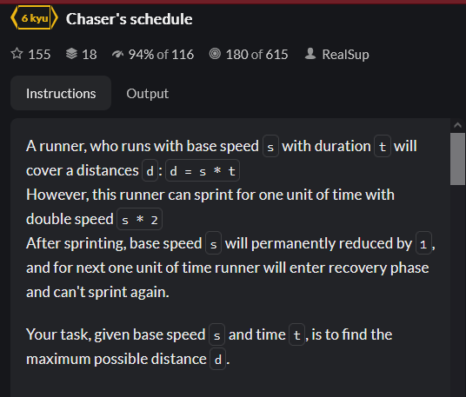

WAS DONE PREVIOUSLY:

MY SOLUTION:

* Algorithm first finds all possible sequences, i.e. combinations of running and sprinting.
* Algorithm then converts this to numbers according to the rules
* The maximum is then found